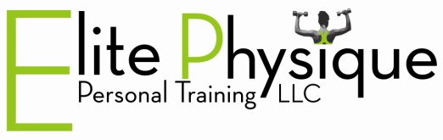
If you have a cooler:
Grapes: refreshing and full of antioxidants and vitamins
String cheese: fun and easy to peel and as a bonus you are getting a good source of calcium
Watermelon: delectable thirst quencher and full of vitamin C and lycopene
Yogurt: delicious and great source of protein and calcium (just beware of the added sugar)
Water: forget the juice boxes and sodas! Pure water is the best way to stay hydrated on your active outings. No calories, fat or sugar…just plain refreshing!
No cooler ideas:
Apples: tasty portable nutrition that’s full of fiber and vitamins. “An apple a day keeps the doctor away” isn’t just an old saying….it’s the truth!
Bananas “the bicyclist’s best friend”: easy to pack and eat on the go. Excellent source of potassium to help as you stay active on your outing. Bananas are an excellent source of B6 as well.
Homemade trail mix: throw some nuts, cereal (like Kashi Go Lean) and some dried fruit into a bag and toss in your backpack for a quick energy boost. Just be careful to watch the added sugar.
Lunch options:
If you want to pack a picnic and head down to the beach, here are some tasty, healthy options;
PB&J: made with natural peanut butter (stay away from partially hydrogenated oils and added sugar), whole wheat bread, and low sugar jelly
Wraps: get whole wheat wraps and place your favorite lunch meat, lettuce, cheese, and peppers. Add mustard instead of mayo to keep the fat and calories down. A great substitute for mayo is avocados! Spread some on your wrap and get the bonus of vitamins and the “good” fat.
Hummus and veggies like baby carrots, celery, and cucumbers. If you need chips, choose natural ones like Stacey’s or Sunchips. Check the ingredients and make sure to stay away from partially hydrogenated oils…your body can’t process them so they end up being stored as fat!
www.ElitePhysiquePT.com
850-598-7263
Colleen@ElitePhysiquePT.com

